Ladies’ Ascot Day at the Races
FORTHCOMING EVENTS AT MMGC

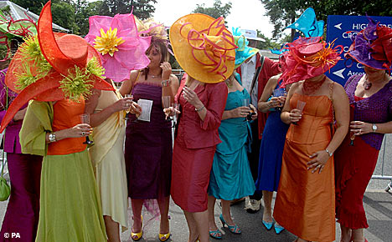

Thursday 20th June 3.00 – 5.30pm
Prosecco Afternoon Tea
includes a selection of finger sandwiches, fruit scones with clotted cream, cup cakes, lemon shots and a glass of Prosecco each

Tickets £15 to include a lucky dip bet on the races and a prize for the best hat!!
(please purchase tickets from the office)
Open to the public - Everyone welcome

